DECEMBER 1999

STATE OF CALIFORNIA
AIR RESOURCES BOARD

STANDARD OPERATING PROCEDURE FOR THE CERTIFICATION OF HIGH FLOW TRANSFER STANDARDS OR HIGH VOLUME ORIFICES USING A LABORATORY PRIMARY FLOW STANDARD

MLD METHOD 5723

Principal Author:
Roderick Lapurga

Reviewed and Approved By
Clifford Popejoy

STANDARDS LABORATORY / PROGRAM EVALUATIONS AND STANDARDS SECTION
QUALITY MANAGEMENT AND OPERATIONS SUPPORT BRANCH
MONITORING AND LABORATORY DIVISION
1927 T STREET
SACRAMENTO, CA 95814

Version 1
12/31/99

1. INTRODUCTION 1

2. SUMMARY OF METHOD 1

3. ANALYSIS METHOD 1

4. INTERFERENCES AND LIMITATIONS 2

5. INSTRUMENTATION AND EQUIPMENT 2

6. TEST BENCH PREPARATION 3

7. IDENTIFY FLOW TRANSFER STANDARD TYPE 8

8. LEAK CHECK 8

9. DATA SHEET PREPARATION 10

10. CALIBRATION PROCEDURE 12

11. DATABASE ENTRY PROCEDURE 17

12. CERTIFICATION CRITERIA 27

14. CALIBRATION CRITERIA 28

- QUALITY CONTROL CRITERIA AND ACTIONS 28

- MAINTENANCE 29

- INTRODUCTION

  - The Standards Laboratory certifies High Volume Orifices, for use as high flow transfer standards, on an annual basis. These transfer standards are certified against a high flow primary standard traceable to the National Institute of Standards and Technology (NIST). High flow transfer standards are used to calibrate the flow rate of particulate matter (PM) samplers in the field. PM samplers are used to support programs based on particulate matter pollution measurements.

  - This standard operating procedure outlines the certification process of high flow transfer standards.

  - This procedure will determine the high flow transfer standard’s ability to accurately and precisely measure flow.

- SUMMARY OF METHOD

  - METHOD NOMENCLATURE

    - Certification - establishes traceability of a flow transfer standard to the NIST traceable primary flow standard. The certification of a flow transfer standard requires the results of four calibrations to meet criteria established by the Standards Laboratory.

    - Transfer Standard - a transportable device or apparatus that is capable of accurately measuring airflow used to calibrate samplers in the field. The precision and accuracy of these types of instruments must be characterized through a certification process. An instrument can be used as a transfer standard provided that its performance, determined through the certification process, meets specified criteria (refer to section 12).

    - High Flow Primary Standard - a gravimetric or volumetric displacement device capable of accurately measuring gas flow rates. A primary flow standard must also be NIST-traceable and checked biennially against a similar device.

- ANALYSIS METHOD

  - The Standards Laboratory uses a NIST-traceable Roots Meter as a primary flow standard. Flow rate is determined by dividing displaced volume by the elapsed time, correcting for ambient temperature, inlet pressure, and barometric pressure.

  - The high flow transfer standard is affixed to the inlet of the primary standard. Attached to the high flow transfer standard venturi port is a differential pressure-measuring device. Airflow through the orifice is correlated to a differential pressure, which is standardized to 760 mmhg and 25° C. This pressure is then compared directly to the primary standard’s flow rate and evaluated statistically to determine the flow characteristics of a high flow transfer standard.

- INTERFERENCES AND LIMITATIONS

  - Ensure all tubing is properly intact and without holes.

  - If the high flow transfer standard under test uses an electronic measuring device to measure differential pressure, verify that it has warmed up for about 30 minutes prior to testing.

  - Inspect the neoprene gasket at the base of the high flow transfer standard for damage or foreign objects, which may compromise the leak check (section 8., page 8) and subsequently the calibration.

- INSTRUMENTATION AND EQUIPMENT

  - NIST traceable Roots Meter

  - Water Manometer (0-50 in. H₂O)

  - Water Manometer (0-16 in. H₂O)

  - Magnahelic (0-1 in. H₂O)

  - NIST Traceable Stopwatch (Digital)

  - 4 Rubber Stoppers

  - 1 Small Rubber Mat

  - Variable High Voltage Regulator (VARIAC)

  - High Volume Air Motor

- TEST BENCH PREPARATION

  - 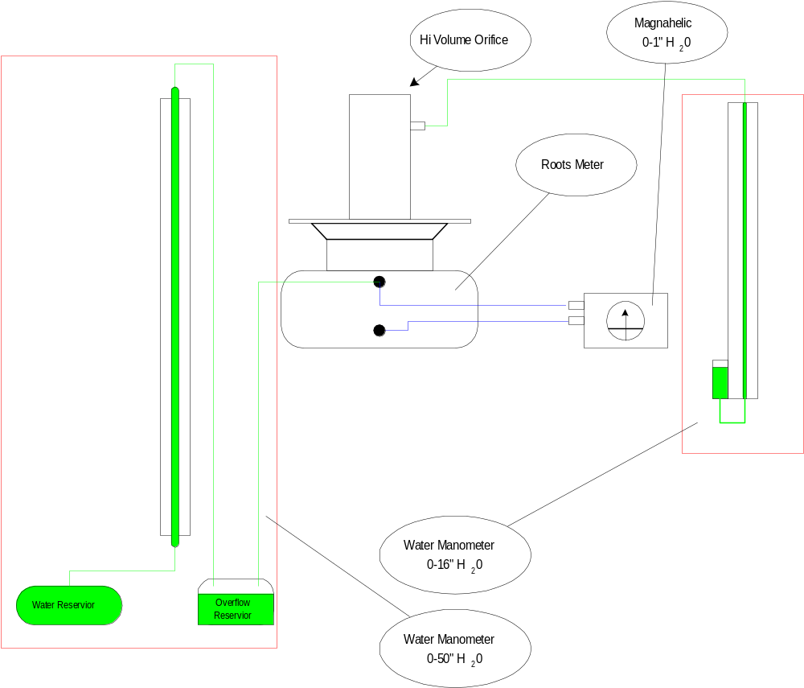Verify the High Flow Volume test bench is configured correctly. Refer to figure 1.
Figure 1

  - Remove the plastic dust cover from the Roots Meter / High Volume Orifice interface.

  - Verify the VARIAC is switched off and dialed fully counterclockwise. The power switch of the VARIAC is a toggle switch located on the outlet side of the unit.

  - Verify the 50-inch water manometer, 16-inch water manometer, and magnahelic are all set to zero.

    - Zeroing the 50-inch water manometer

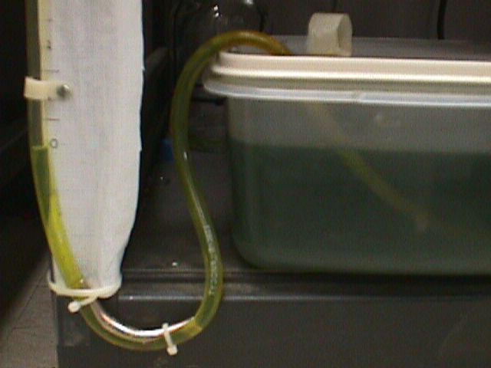
      - Adding or removing water from the water reservoir will adjust the meniscus level to the zero marker.
Figure 2

    - Zeroing the 16-inch water manometer.

      - Located at the base of this water manometer, is an adjustment ring, which is used to raise or lower the scale. Align the zero marker of the scale to the meniscus of the water.
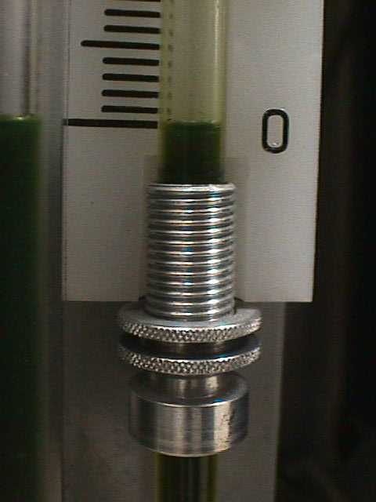
Figure 3

    - Zeroing the Magnehelic

      - Located at the center of the front face, is an adjustment screw.

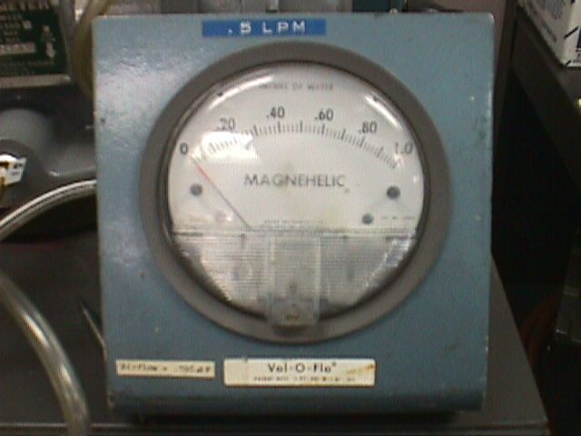
      - Turn the screw clockwise or counterclockwise until the needle is lined up with the zero marker of the scale.
Figure 4

  - Configure the NIST traceable digital stopwatch.

    - Verify the stopwatch is in the proper mode.

      - Locate and press the mode button repeatedly until the stopwatch mode is displayed and 1/1000m is selected. The stopwatch mode can be identified by the following field headings:

- Split
- Lap
- Stop

    - Verify the stopwatch reads zero.

      - If zero adjustment is required, locate the reset button and press it once.

    - Check the high flow transfer standard’s neoprene gasket for tears and or foreign material. An airtight seat is essential to pass the leak test.

    - The high flow transfer standard can be broken down into two parts, which are the orifice and the base plate. Verify the orifice is screwed tightly against the base plate.

    - Place the high flow transfer standard on the Roots Meter interface assembly so that the differential pressure gage (if attached) is facing the user. Note: Sometimes clients ship their high flow transfer standards without a gauge.

      - If the high flow transfer standard does not have a differential pressure gauge, use the laboratory’s 0-16 in. H₂O manometer attached to the test bench.

      - Via tygon tubing, attach the water manometer to the venturi port of the high flow transfer standard.

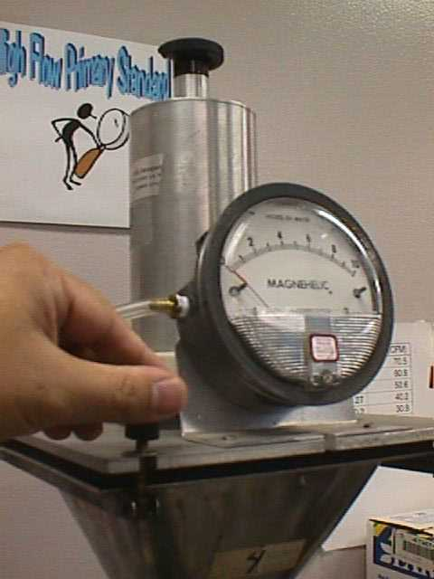
    - Secure the high flow transfer standard to the Roots Meter interface assembly using four wing nut screws.
Figure 5

      - Hand tighten each wing nut in the following order.

- Wing Nut 1
- Wing Nut 4
- Wing Nut 3
- Wing Nut 2
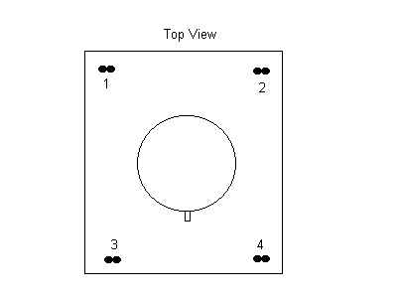
Figure 6

      - Repeat step 6.5.6.1 until all wing nuts are tight.

      - Switch the VARIAC on and turn the black dial clockwise until the display reads ≈ 70 volts AC. A steady flow of air should now be passing through the Roots Meter

      - Repeat step 6.5.6.1 until all wing nuts are hand tight.

      - Switch the VARIAC off and turn the black dial fully counterclockwise.

- IDENTIFY THE HIGH FLOW TRANSFER STANDARD TYPE

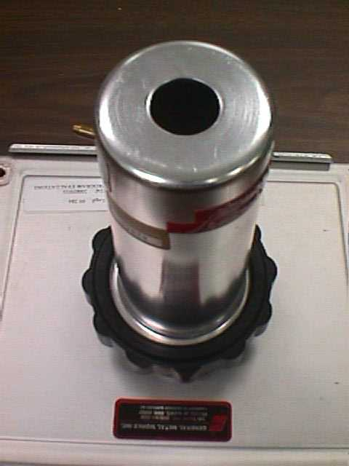
  - Fixed Type

7.1.1 A fixed high flow transfer standard consists of a single air intake hole of specific diameter. Refer to the figure at right.

Figure 7

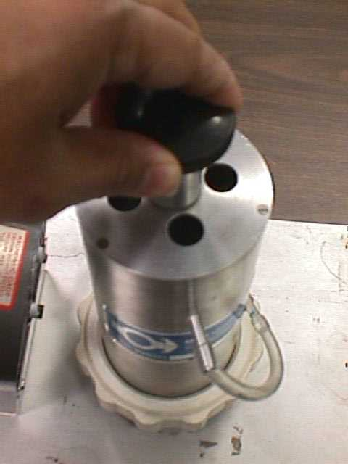
7.2 Variable Type

7.2.1 A variable high flow transfer standard consists of four air intake holes and an adjustment knob, which changes airflow through the orifice.

Figure 8

  - Fixed Type w/ Plates

    - This type of high flow transfer standard is similar to the fixed type explained in step 7.1. Five restriction plates are used interchangeably and one at a time to vary the flow rate characteristics.

- LEAK CHECK

  - Disconnect three tygon tubes from the Roots Meter and replace them with plugs (blanked tubing).

  - If the high flow transfer standard comes with a differential pressure-measuring device, disconnect it from the venturi port (refer to figure 7).

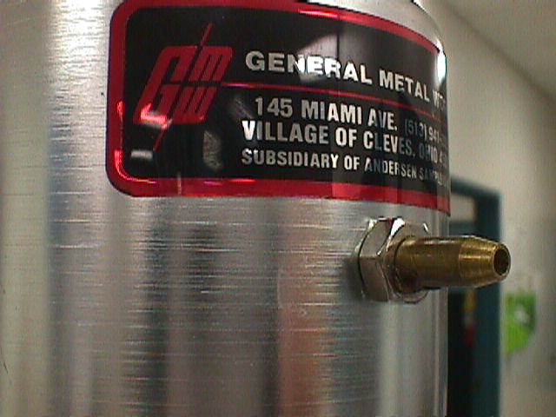

    - Attach a plug to the venturi port of the high flow transfer standard.
Venturi Port
    - Turn on the VARIAC and rotate the black dial clockwise until the display reads ≈ 60 volts AC.
Figure 7

    - While monitoring the Roots Meter counter, block the airflow through the high flow transfer standard. If the high flow transfer standard is the variable type, skip to step 8.2.3.2, otherwise continue to the next step.

      - Fixed high flow transfer standard.

        - Block the flow by placing a small rubber mat over the air intake hole. Monitor the Roots Meter counter and verify that it does not move for 20 seconds. A leak is indicated by a slow creep of the Roots Meter counter (last digit) and must be resolved before a calibration can be performed.

CAUTION

Do not block the air intake for more than 2 minutes; doing so can damage the high volume air motor.

        - If a leak exists, rotate the VARIAC dial fully counterclockwise; turn off the VARIAC and repeat steps 6.5.3 to 6.5.6.5. Consult laboratory staff if the leak persists.

        - Skip to step 8.2.4

      - Variable High Flow Transfer Standard

        - Turn the flow adjustment knob on the high flow transfer standard for maximum flow.

        - Block the flow by placing a rubber stopper in each of the 4 holes. Monitor the Roots Meter counter and verify that it does not move for 20 seconds.

CAUTION

Do not block the air intake for more than 2 minutes; doing so can damage the high volume air motor.

        - If a leak exists, rotate the VARIAC dial fully counterclockwise; turn off the VARIAC and repeat steps 6.5.3 to 6.5.6.5. Consult laboratory staff if the leak persists.

    - Rotate the black control dial on the VARIAC fully counterclockwise.

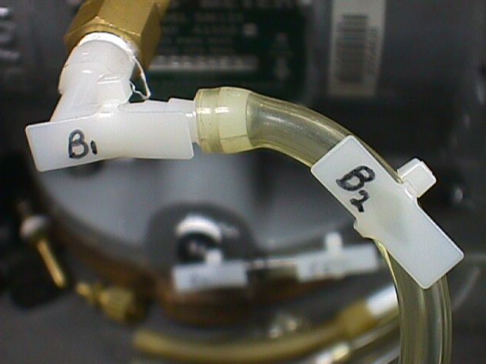
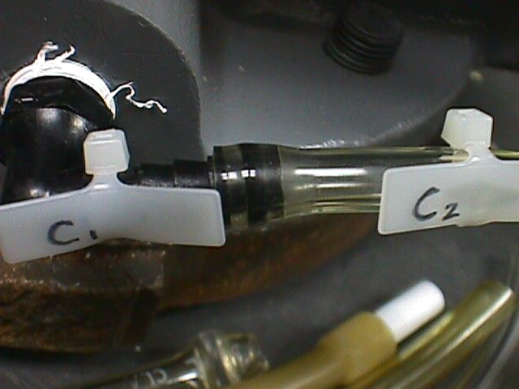
8.2.5 Remove all blanked off tubing applied in steps 8.1 and 8.2.1 and reconnect the test bench to its original configuration. Be sure to match letter designations. Refer to figures 9, 10, and 11.
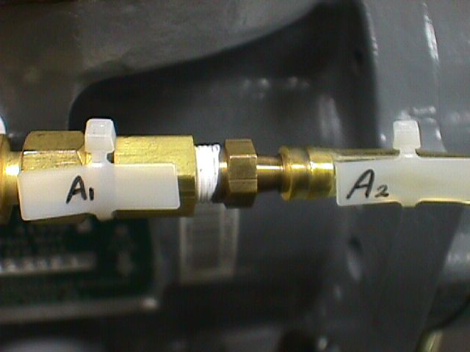
Figure 9
Figure 10
Figure 11

- DATA SHEET PREPARATION

  - Obtain data sheet and record preliminary data. Figure 12 shows an example of the high flow transfer standard’s calibration worksheet.

- Log Number
- Property Number or Barcode Number
- Agency Name
- Date
- Roots Meter Property Number
- Barometer Pressure (Refer to Barometer SOP)
- User’s Name
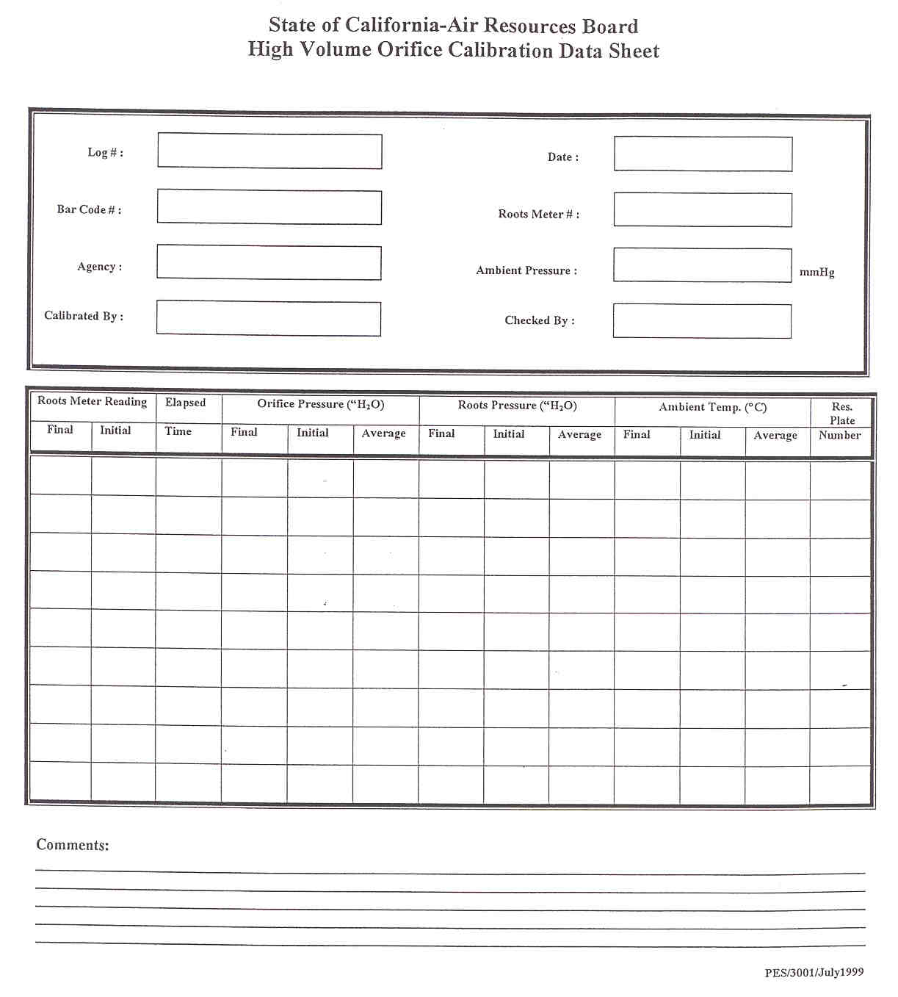
Example of the high flow transfer standards calibration worksheet.
Figure 12

- CALIBRATION PROCEDURE

  - If the high flow transfer standard is:

- Fixed Type, skip to step 10.2.
- Variable Type, skip to step 10.3.
- Fixed Type with Restriction Plates, skip to step 10.4

  - Fixed High Flow Transfer Standard

    - The following table consists of flow settings at which flow samples are taken.

Flow Point Number | Magnehelic Display (inches of H₂O) | Flow  (ft³/min)
1 | 0.57 | 70.5
2 | 0.46 | 60.6
3 | 0.36 | 50.6
4 | 0.27 | 40.2
5 | 0.20 | 30.8
6 | 0.13 | 19.7

CAUTION

Make sure the maximum pressure in the 50-inch H₂O manometer is not exceeded. Over-pressurization can cause water to overflow into the Roots Meter.

    - Adjust the VARIAC control knob clockwise until the Magnehelic on the test bench displays the first flow point of 0.57 inches of H₂O, which translates to 70.5 ft³/min.

    - Wait approximately 5 minutes for the flow to stabilize.

    - As airflow passes through the Roots Meter, the attached counter will increment. Pre-select an initial Roots Meter counter reading. As soon as the pre-selected reading is achieved, perform the following:

- Start the stop-watch and note the counter reading
- Record the initial Roots Meter counter
- Record the initial orifice pressure
- Record the initial Roots Meter pressure
- Record the initial ambient temperature.

    - Allow airflow to pass through the high flow transfer standard and Roots Meter for at least 3 minutes.

    - At the end of 3 minutes, perform the following.

- Stop the stop-watch and note the counter reading
- Record the final Roots Meter counter
- Record the final orifice pressure
- Record the final Roots Meter pressure
- Record the final ambient temperature

    - Repeat steps 10.1 to 10.2.6 until all flow points in the table of the previous page have been sampled.

    - Turn the black dial of the VARIAC fully counterclockwise and switch the power switch to the off position.

    - Skip to section 11.

  - Variable High Flow Transfer Standard

    - The following table consists of flow settings at which flow samples are taken.

Flow Point Number | Magnehelic Display (inches of H₂O) | Flow  (ft³/min)
1 | 0.57 | 70.5
2 | 0.46 | 60.6
3 | 0.36 | 50.6
4 | 0.27 | 40.2
5 | 0.20 | 30.8
6 | 0.13 | 19.7

    - Dial the adjustment knob of the high flow transfer standard for maximum flow.

    - Slowly adjust the VARIAC control knob until the Magnehelic displays the first flow point of 0.57 inches of H₂O, which translates to 70.5 ft³/min.

CAUTION

Make sure the maximum pressure in the 50-inch H2O manometer is not exceeded. Over-pressurization can cause water to overflow into the Roots Meter.

    - Wait approximately 5 minutes for the airflow to stabilize.

    - As airflow passes through the Roots Meter, the attached counter will increment. Pre-select an initial Roots Meter counter reading. As soon as the pre-selected reading is achieved, perform the following:

- Start the stop-watch and note the counter reading
- Record the initial Roots Meter Counter
- Record the initial orifice pressure
- Record the initial Roots Meter pressure
- Record the initial ambient temperature

    - Allow airflow to pass through the high flow transfer standard and Roots Meter for at least 3 minutes.

    - At the end of 3 minutes, perform the following.

- Stop the stop-watch and note the counter reading
- Record the final Roots Meter counter
- Record the final orifice pressure
- Record the final Roots Meter pressure
- Record the final ambient temperature

    - Repeat steps 10.3 to 10.3.8 until all flow points in the table of the previous page have been sampled.

    - Turn the black dial of the VARIAC fully counterclockwise and switch the power switch to the off position.

  - Fixed High Flow Transfer Standard w/ Restriction Plates

    - With no restriction plates installed, adjust the VARIAC control knob clockwise until the Magnehelic on the test bench displays 0.57 inches of H₂O.

    - Wait approximately 5 minutes for the airflow to stabilize.

    - As airflow passes through the Roots Meter, the attached counter will increment. Pre-select an initial Roots Meter counter reading. As soon as the pre-selected reading is achieved, perform the following:

- Start the stop-watch and note the counter reading
- Record the initial Roots Meter Counter
- Record the initial orifice pressure
- Record the initial Roots Meter pressure
- Record the initial ambient temperature

    - Allow airflow to pass through the high flow transfer standard and Roots Meter for at least 3 minutes.

    - At the end of 3 minutes, perform the following.

- Stop the stop-watch and note the counter reading
- Record the final Roots Meter counter
- Record the final orifice pressure
- Record the final Roots Meter pressure
- Record the final ambient temperature

    - Turn off the VARIAC. Do not touch the control dial.

    - Remove the high flow transfer standard from the Roots Meter interface assembly and install a restriction plate.

    - Replace the high flow transfer standard on the Roots Meter interface assembly and turn the VARIAC on.

    - Perform a leak check (refer to step 8.2.3.1)

    - Repeat steps 10.4.2 to 10.4.9 until all restriction plates have been sampled.

    - Turn the black dial of the VARIAC fully counterclockwise and switch the power switch to the off position.

- DATABASE ENTRY

  - From any computer within the Standards Laboratory, initiate the Instrument Management System (IMS) Software.

  - Locate and double-click the Instrument Management System Icon. Refer to figure 13.


Figure 13

  - From the main menu select option 3, “Instrument Calibration”. Refer to figure 14.
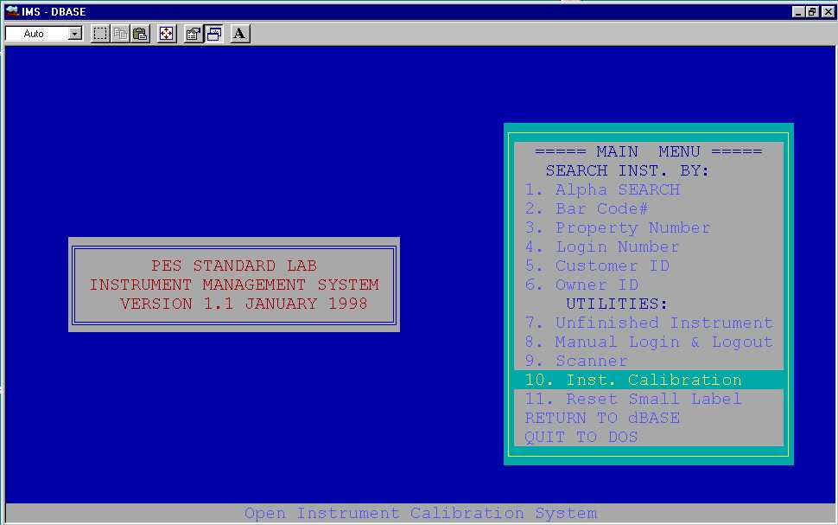
Figure 14

  - Enter the bar code number of the high flow transfer standard. This bar code number usually begins with 107 or 2000 and is located on the orifice piece of the high flow transfer standard’s assembly. Refer to figure 15.
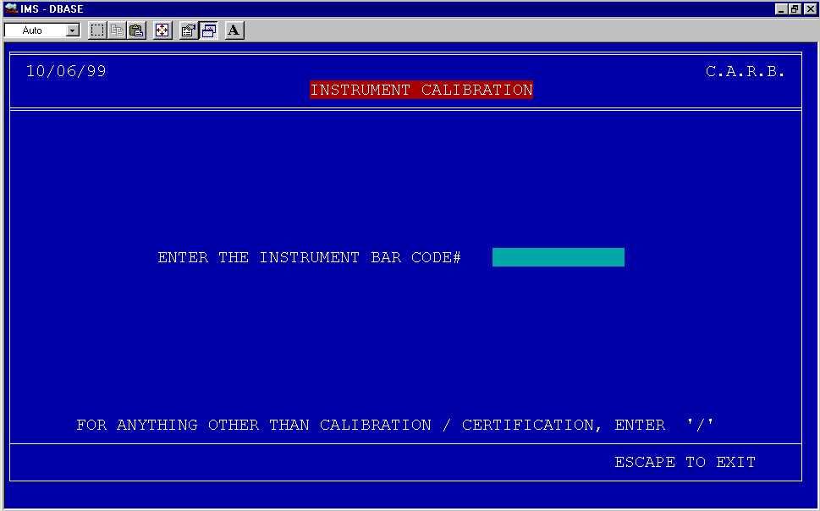

Figure 15

11.5 Enter the log number and date. Refer to figure 16.
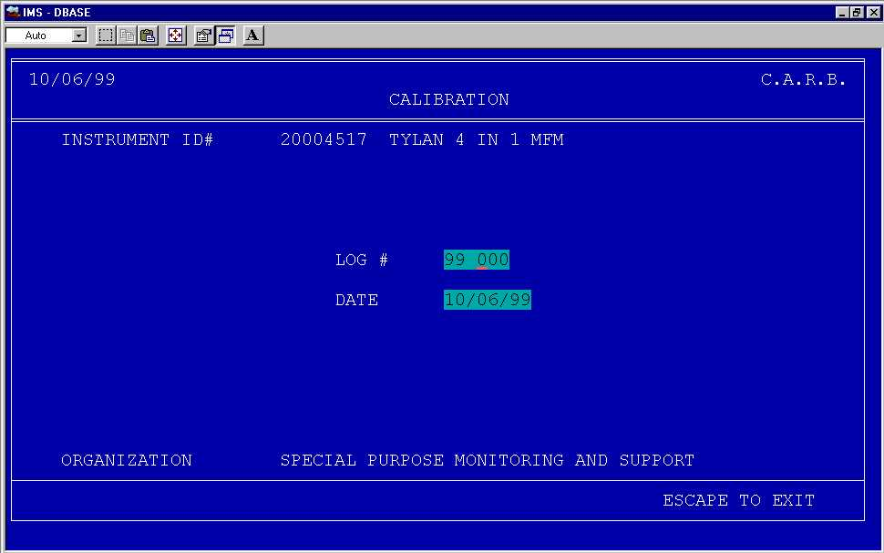
Figure 16

  - Enter the number of sample points taken and barometric pressure reading. Refer to figure 17.
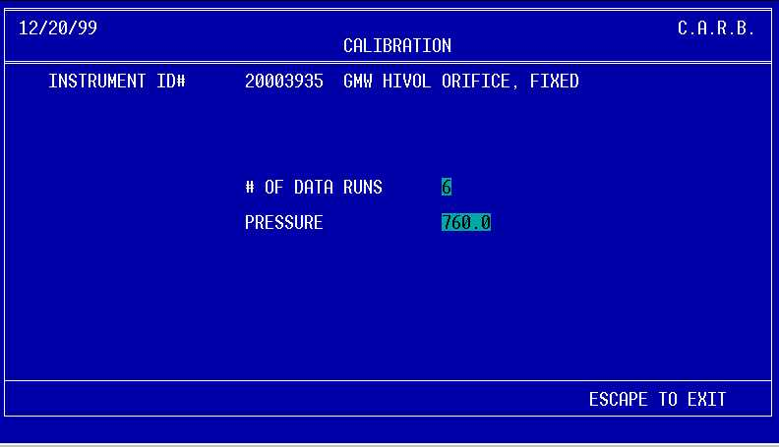
Figure 17

  - Enter data from calibration worksheet. Refer to figure 18.
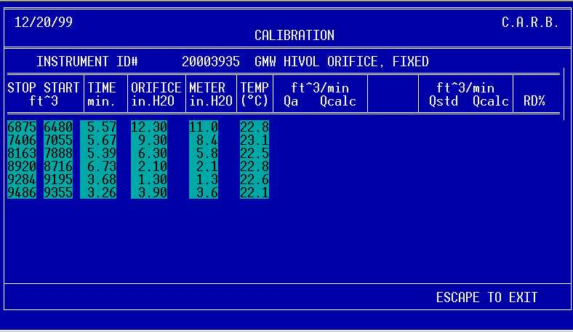

Figure 18

  - As the last piece of data is entered, Qa and Qstd will automatically be calculated. Refer to figure 19.

    - Qa – Actual flow

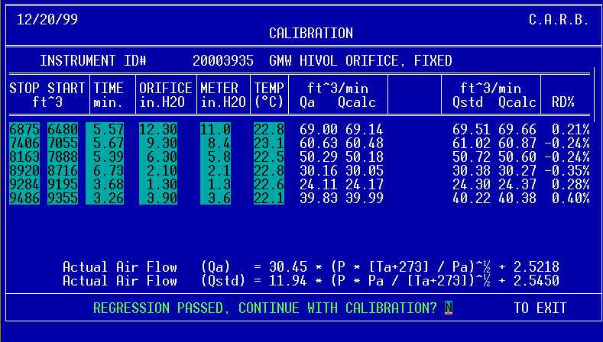
    - Qstd – Corrected flow to standard conditions of 760mmHg and 25°C
Figure 19

  - Two separate regression analyses are performed.

- Regression 1: high flow transfer standard pressure and Qa
- Regression 2: high flow transfer standard pressure and Qstd

    - 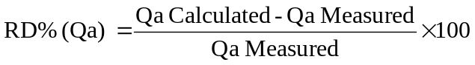Each regression analysis must pass the correlation coefficient criterion of ≥ 0.9999. Each flow point must also pass a Qa relative deviation (RD%) criterion of ≤ 1%.

      - A statement on the bottom of the screen will indicate if the regressions passed or failed.

        - Pass

          - The bottom of the screen will indicate that the regression has passed. Refer to figure 19.

          - The user will then be given the option to continue with the calibration or not. Type Y then enter.

          - If the RD% criterion for each sample is met, skip to step 11.8.1.1.1.5, otherwise, continue to the next step.

          - If the RD% criterion is not met, the user flags this calibration “bad” by typing 3 then enter. Exit the IMS. This completes the calibration process.
Another calibration attempt must be performed and on a different day.

          - If both the regression and RD% criteria are met, print the calibration data by typing 1 then enter. Note: This will be the only time calibration data can be printed out. The IMS does not save this data in its database.
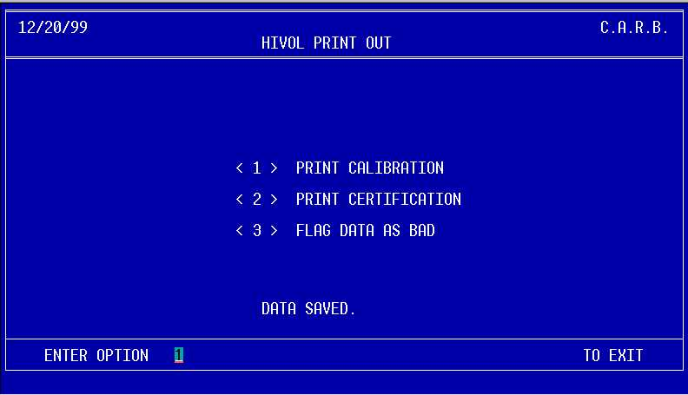
Figure 20

          - Print the certification by typing 2 then enter. At this point, the certification criteria will be checked.

            - If the high flow transfer standard passes these criteria, a certification record and report will be printed. Below is a list of the certification criteria.

Regression 1 and 2:
- Relative Standard Deviation (Slope) < .007
- Relative Standard Deviation (Intercept) < .007

11.8.1.1.1.6.2 If the high flow transfer standard fails the certification criteria, the following screen will be displayed. Press the esc key and exit IMS. Another calibration attempt must be performed and on a different day (refer to section 12).
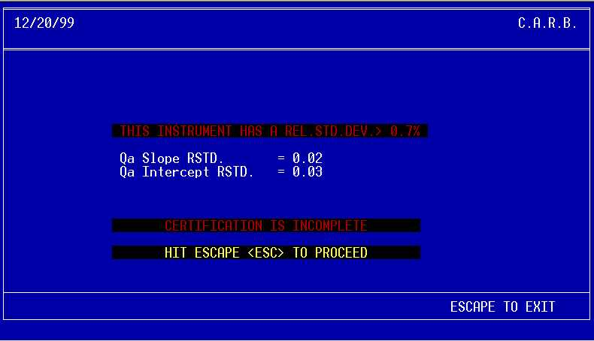
Figure 21

        - Fail

          - The bottom of the screen will indicate that the regression has failed. The user is given the option to enter N to edit the entry or Y to accept the entry. Review the data and verify it has been entered correctly. If an entry error is found, press the N key on the keyboard to re-enter data otherwise, press the Y key.
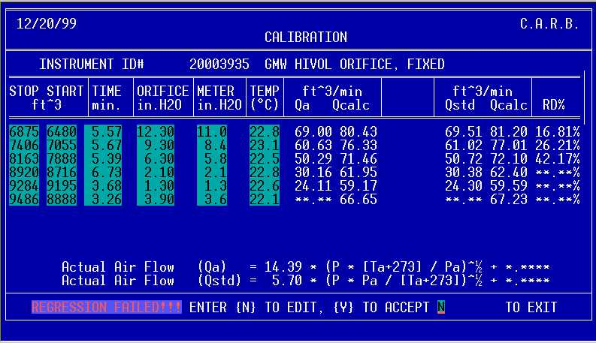

Figure 22

          - The next screen is self-explanatory. Typically, a calibration sheet for a failed regression is not printed out.

Figure 23

- CERTIFICATION CRITERIA

  - A certification requires 2 consecutive assays each performed on different days. This ensures that each assay is performed at a different ambient condition (temperature and barometric pressure) than the previous assay. This practice checks the stability of the guest flow instrument. Each assay must have a linear regression subjected to a correlation coefficient criterion of ≥ 0.9999.

  - A valid certification consists of the following:

- Slope RSD% consisting of the latest assay from the current certification process to the previous assay must be less than 0.7 percent.

- Intercept FRSD% consisting of the latest assay from the current certification process to the previous assay must be less than 0.7 percent.

- CALIBRATION CRITERIA

  - A calibration is composed of a single assay which yields two slope and
Intercept formulas.

- actual airflow (Qa)
- standard airflow (Qstd).

13.2 These formulas are used to correct the display of the high flow transfer standard only if the correlation coefficient is ≥ 0.9999. In addition, a relative deviation criterion of ≤ 1 percent for each sample must also be met.

13.3 Instrument calibrations do not provide NIST traceability.

- QUALITY CONTROL CRITERIA AND ACTIONS

  - Leak Check

  - Leak checks are performed on the primary flow standard and the high flow transfer standard before each calibration. Please refer to section 8.

  - The traceability of the Roots Meter is verified biennially.

    - The verification of the Roots Meter is performed by Dresser, the manufacturer, using a multi-point comparison with a positive displacement bell prover. A least-squares linear regression equation is calculated from the comparison. The regression must have a correlation coefficient of 0.9999 or greater. The slope must be within 1.5 percent RSD of the expected value and the intercept less than 0.5 percent FRSD.

  - A control check for the Roots Meter is performed quarterly using a dedicated high volume orifice ARB#20003935 with a water manometer.

    - A correction factor derived from the linear regression equation is used. Each calibration point must fall within 1 percent of the regression line; if not, the point must be rerun. The last two calibration’s slopes must have an RSD of ± 0.7%. After the slope is established, it is compared to all historical control orifice slopes. The new calibration’s slope should be ± 3 standard deviations of the mean of all prior quarters’ slopes. For reference, a control chart is available in the latest quarterly QC Report.

      - Quality Control Actions

        - RSD Violations

          - If the RSD is greater than 0.7%, the Roots meter, orifice and all connections are inspected and the test is repeated.

        - Control Limit Violations

          - If the slope falls outside these limits, troubleshooting is initiated and repairs are performed as needed. A slope > ± 2 and < ±3 standard deviations is considered to be in the warning region, which initiates a data review. An exceedance of ± 3 standard deviations of the mean will trigger a control action. This action involves stopping and investigating the process, and reviewing any data that may have been effected. If warranted, instruments may be recalled from field use for reanalysis.

  - A pressure gauge (Magnehelic, figure 4) is used to perform an operational test by measuring the pressure drop across the Roots meter for both the starting threshold and the maximum rated flow of 5000 ft³ per hour.

    - The operational test is performed annually and is done without a high flow transfer standard affixed to the Roots Meter interface assembly.

    - With the VARIAC dial fully counterclockwise, turn on the power.

    - Rotate the VARIAC dial slowly clockwise until the Roots Meter Counter just starts to move. Record the pressure indicated by the Magnehelic; this is the starting threshold. Rotate the dial further clockwise until the Roots Meter has achieved its rated full-scale value or 83.3 ft³/min. Again, record the pressure indicated by the Magnehelic; this is the pressure drop at maximum flow rate. Note: Record all operational test data in the High Flow Primary Standard Maintenance log book.

      - According to the manufacturer, the starting threshold must be less than 0.1 inches of water and the full-scale flow must be less than 1.0 inches of water. If these values are exceeded, the Roots Meter is sent back to the manufacturer for repair.

- MAINTENANCE

  - Biennially, the Roots Meter is drained of its gear oil and sent back to the manufacturer. In addition to the verification, the Roots Meter is thoroughly inspected and repaired if necessary. Upon return, the Roots Meter is filled with new gear oil.

    - To verify the Roots Meter has not significantly changed as a result of the maintenance, Standards Laboratory staff perform two operational tests; one prior to shipping and the other when it returns from the manufacturer (refer to step 14.5).

